Cloud Computing vs On - Premises Deployment
A comparative analysis with "Tax Smile – IT Returns" examples

What is Cloud Computing?
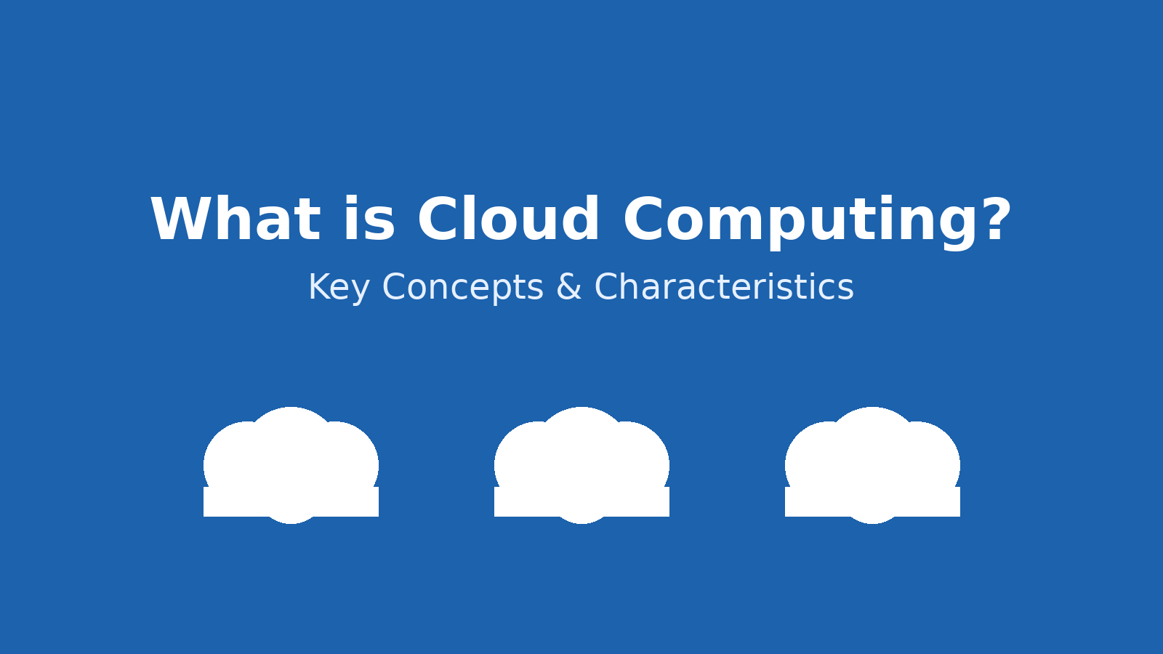
Cloud computing is the on-demand delivery of IT resources such as servers, storage, databases, networking, software, and analytics over the internet with pay-as-you-go pricing. Instead of buying, owning, and maintaining physical data centers and servers, organizations can access technology services from a provider as needed. Key characteristics include on-demand self-service, broad network access, resource pooling, rapid elasticity (scaling up/down), and measured service (usage-based billing).

Advantages of Cloud Computing
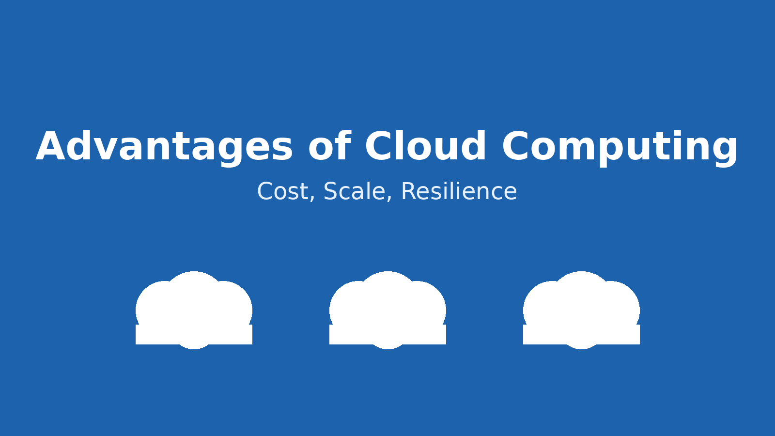
• Cost Efficiency: Reduce capital expenditure (CapEx) by avoiding upfront hardware purchases; shift to operational expenditure (OpEx) with pay-as-you-go pricing.
• Scalability & Elasticity: Scale resources up or down automatically based on demand (e.g., load testing periods) without manual hardware provisioning.
• Speed & Agility: Provision environments in minutes; accelerate experimentation and time-to-market.
• Reliability & Resilience: Built-in redundancy across regions/availability zones; robust disaster recovery and backup options.
• Global Reach: Deploy closer to users around the world through provider data centers; improve latency and user experience.
• Security & Compliance: Benefit from provider security investments and certifications while retaining shared responsibility for workloads.
On-Premises Deployment vs Cloud Deployment
Aspect | On-Premises | Cloud | Notes
Cost Model | High CapEx for hardware, facilities | OpEx with pay-as-you-go pricing | CapEx vs OpEx implications
Provisioning Time | Weeks to months (procurement, setup) | Minutes to hours (self-service) | Faster experimentation in cloud
Scalability | Manual, constrained by capacity | Automatic elastic scaling | Handles peaks like APR–AUG filing
Maintenance | In-house hardware upkeep | Provider manages infrastructure | Shared responsibility model
Availability | Depending on single site redundancy | Multi-AZ/Region options | Improved resilience
Performance Testing | Needs extra physical servers | Spin up temporary VMs/instances | Deprovision when done
Security | Full control, but full responsibility | Advanced features + shared responsibility | Compliance considerations

On-Premises Architecture (example):
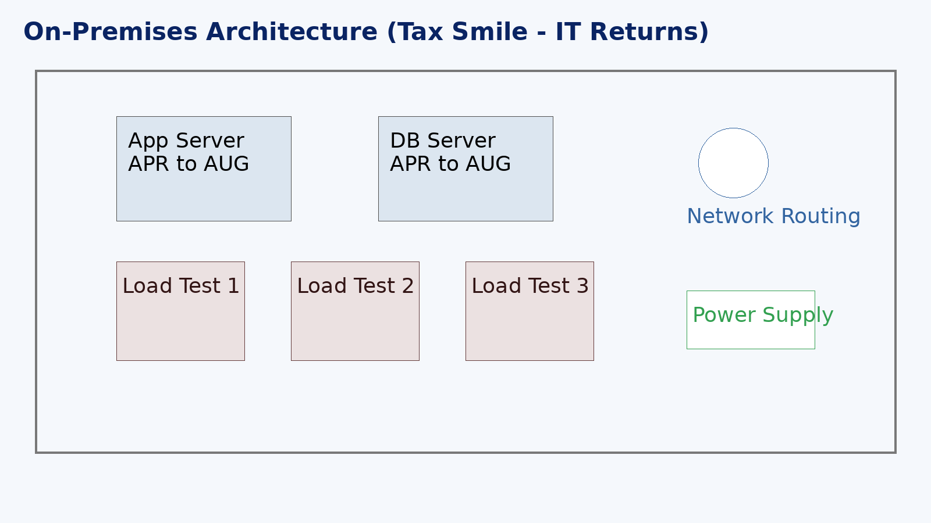
Cloud Architecture (example):
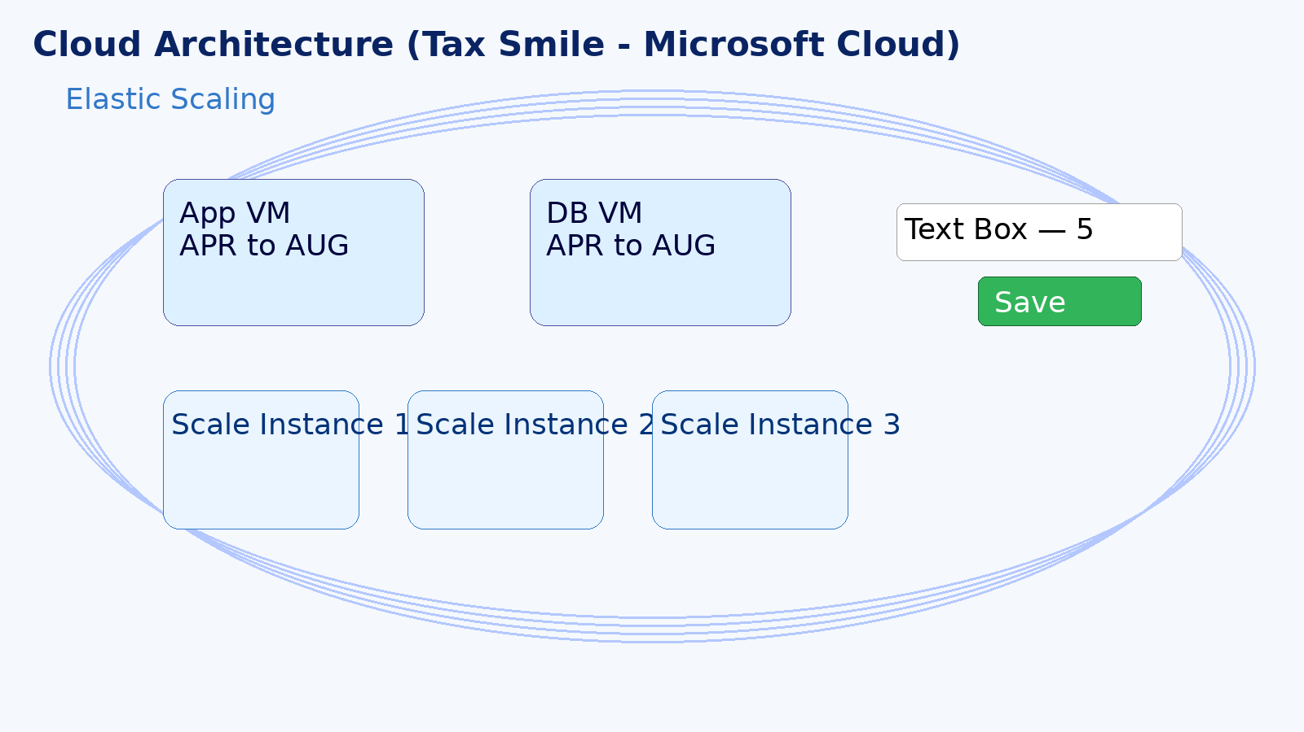

Framework: Tax Smile — IT Returns — On-Prem Solution
Baseline: 2 Servers — Architecture — APR till AUG (filing season).
Load Testing & Stress Testing: add 3 more servers.
Steps:
1) Get approvals from stakeholders — Directors, CTO, COO.
2) Buy 3 servers from vendor (Germany) — 30 days lead time.
3) Retrofit inside server room — Network Engineers — 24/7 — 3 Teams + 1 Team — Routing.
4) Rent for the room (facility costs).
5) Ensure adequate power supply and UPS.

Framework: Tax Smile — IT Returns — Microsoft Cloud Solution
Baseline: 2 VMs — Architecture — APR till AUG.
Load Testing & Stress Testing: add 3 more instances (temporary).
Features:
• Elastic scaling — increase/decrease capacity as needed.
• UI elements: Text Box — 5 — Save Button (sample control).
Suggested Steps:
1) Get approvals from stakeholders (Directors, CTO, COO).
2) Provision VMs and services in Microsoft cloud (minutes).
3) Configure networking, routing, security groups, and monitoring.
4) Set autoscale rules for peak APR–AUG periods.
5) Deprovision test instances after load/stress cycles to save costs.

